Developing stage-discharge rating curves for two sites at Papa Stream, Nu’uuli Village, American Samoa

Alex T. Messina a

*a San Diego State University, Department of Geography, San Diego, CA 92182, amessina@rohan.sdsu.edu, +1-619-594-5437*

Submitted December 11, 2015

**Abstract.** Stage-discharge rating curves were developed for two stream gaging sites on Papa Stream in Nu’uuli Village, Tutuila, American Samoa.

1. Introduction

Coral reefs around the world are threatened by increased sediment stress caused by human disturbance of the landscape and increased erosion. Suspended sediment attenuates light for photosynthesis, accumulates on corals, and blocks sights for larval recruitment. Successful management and sediment load reduction requires identifying key sediment sources and quantifying their contributions to the total loading from the watershed. Field-based approaches have focused on measuring the suspended sediment load discharged by the watershed (or subwatersheds), using stream gaging techniques. Suspended sediment yield is calculated directly from measurements of water discharge and sediment concentration, so the measurement of stream discharge is critical for the analysis of sediment loads. The most common field technique for monitoring continuous water discharge in a natural stream is to develop a stage-discharge rating curve from field measurements of water discharge. The rating curve is then used to convert continuous stream stage measurements to continuous discharge.

The US Geological Survey measured daily mean stage at a stream gaging site in the study watershed (USGS 16944200) from 1966-1976. Peak mean daily flows over the ten year period varied from 0 - 6,343 L/sec (Wong, 1996). The USGS discontinued all operations in the Territory of American Samoa in 2008 so no recent stream gaging data is available.

In the study watershed, two sites were selected to monitor sediment yield from the upper, undisturbed subwatershed (UPPER) and the lower, human-disturbed watershed (LOWER) drained by Papa Stream in Nu’uuli Village, American Samoa. In future work, sediment load will be calculated at these points to determine sediment contributions from each subwatershed to the total sediment load from the watershed. The ultimate goal is to use sediment yield from natural and disturbed areas of Nu’uuli watershed as a baseline for comparison with natural and disturbed areas of nearby Faga’alu watershed, to determine the success of a sediment mitigation project underway in Faga’alu. Sediment runoff from a rock quarry in Faga’alu was significantly degrading coral health in the bay, so structures to retain the sediment were installed in December 2014. There are still other disturbed areas in Faga’alu, so sediment loading from Faga’alu watershed will likely not be reduced to natural background, making it difficult to determine if the project at the quarry was successful. It is hoped sediment loading will be reduced to levels of a “typical” human-disturbed watershed, and this would be considered a success for the project. Nu’uuli watershed is similar to Faga’alu in nearly every watershed characteristic like soil type, climate, and topography, so will provide a useful baseline of sediment yield to compare post-mitigation sediment loading from Faga’alu.

This paper presents the development of stage-discharge rating curves at two sites on Papa Stream which will be used to calculate sediment load. These stage-discharge rating curves will be critical for future analyses of sediment loading from Nu’uuli watershed and will also provide valuable data on flooding, rainfall-runoff relationships, and water supply for the village.

Study Area

The study watershed (Nu’uuli) is a subwatershed of Nu’uuli Village, located on Tutuila (14S, 170W), the largest island in the Territory of American Samoa (140 km²)(Figure 1). Nu’uuli watershed (2.1km2) is drained by Papa Stream, which runs the length of the watershed (~3km), and several small tributaries. Like many volcanic islands in the Pacific, Tutuila is composed of steep, heavily forested mountains with villages and roads mostly confined to the flat areas near the coast. The study watershed includes Matafao Mountain, the highest point on Tutuila (653 m), and the stream discharges into the Pacific Ocean. The mean slope of the watershed is 0.53 m/m and total relief is 653 m.

Precipitation on Tutuila is caused by several mechanisms including cyclones and tropical depressions, isolated thunderstorms, and orographic uplifting of trade-wind squalls over the high (300-600 m), mountainous ridge that runs the length of the island. Unlike many other Pacific Islands, the ridge runs parallel to the predominant wind direction, and does not cause a significant windward/leeward rainfall gradient. From 1903 to 1973, average annual precipitation over the island was 3,800 mm/yr (Eyre, 1989; Izuka et al., 2005). Precipitation increases with elevation, from an average 2,380 mm/yr at the shoreline to 6,350 mm/yr at the highest elevation on the island. There are two subtle rainfall seasons: a drier winter season, from June through September and a wetter summer season, from October through May (Izuka et al., 2005). During the drier winter season, the island is influenced by relatively stronger, predominantly east to southeast trade winds, lower temperatures, lower humidity and lower total rainfall. During the wetter summer season the Inter-Tropical Convergence Zone (ITCZ) moves over the region, causing light to moderate Northerly winds, higher temperatures, higher humidity, and higher total rainfall. While total rainfall is lower in the drier tradewind season, large storm events are still observed.

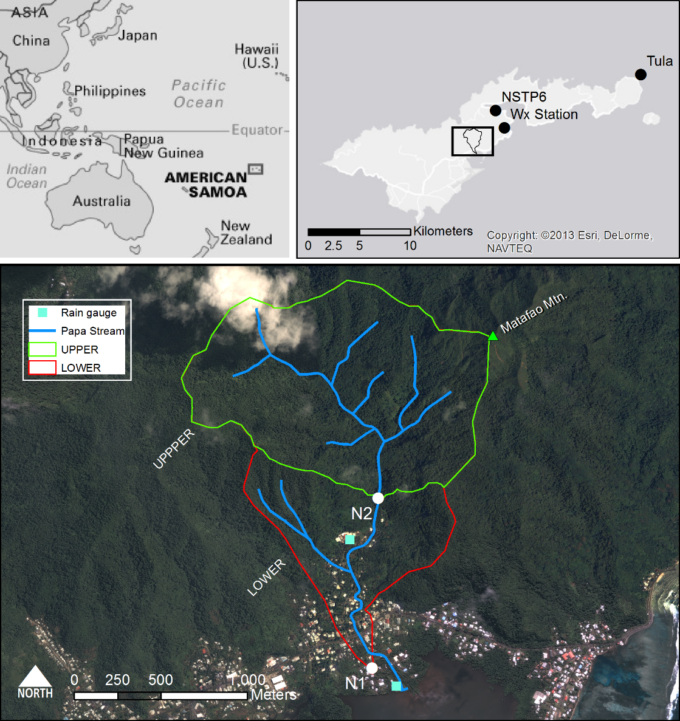

Figure 1. Nu’uuli watershed showing the UPPER (undisturbed) and LOWER (human-disturbed) subwatersheds. The LOWER subwatershed drains areas between N2 and N1. Barometer locations at NSTP6 and TULA shown in top-right.

The predominant land cover in Nu’uuli watershed is undisturbed vegetation (98%), including forest (94%) and scrub/shrub (4.3%) on the steep hillsides (Table 1), based on a land cover map from NOAA’s Ocean Service and Coastal Services Center (2010). The upper watershed (UPPER) is dominated by undisturbed rainforest on steep hillslopes. The lower subwatershed (LOWER) has steep vegetated hillslopes and a relatively small flat area in the valley bottom that is residential houses and small gardens. This settlement pattern is typical in the South Pacific and other volcanic islands, where their small size and steep topography constrain development to valley bottoms near the coast (Bégin et al., 2014).

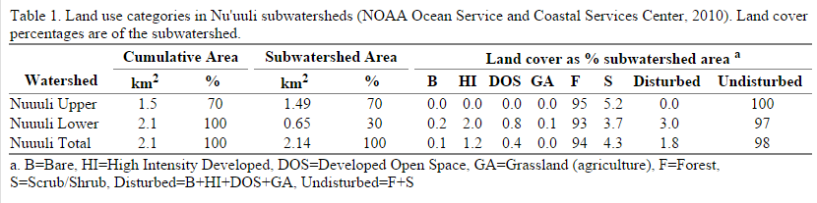

2. Methods

The most common method for measuring discharge is the area-velocity method using a flowmeter (Turnipseed and Sauer, 2010). A Marsh-McBirney flow meter was used to measure flow speed at 0.5 foot intervals across the stream. Discharge was calculated as the sum of flow speed at the midpoint of each interval and the cross-sectional area of that interval. Discharge measurements were taken over a range of flow conditions, and related to stream stage using a log-linear fitting method (power law).

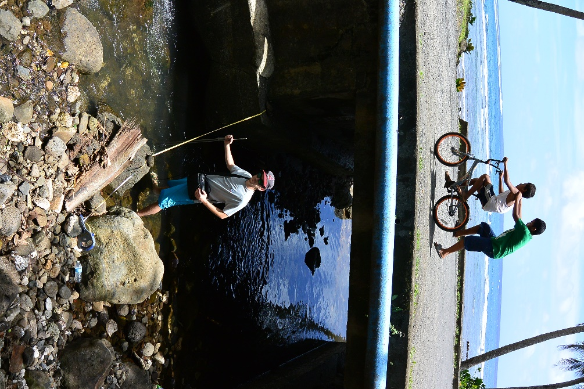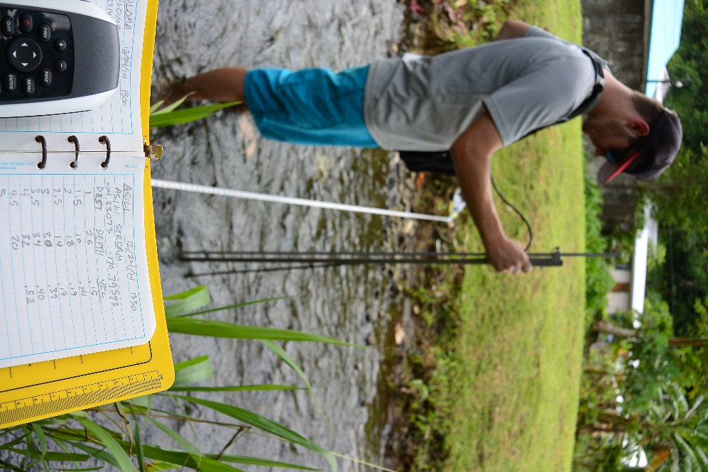

Figure 2. Field assistant Greg McCormick measuring discharge using a Marsh-McBirney flow meter and the area-velocity method. Photos: Messina.

Discharge was also calculated from Manning’s equation for flow in open channels and the cross-sectional area of the channel (Equation 1), which was measured in two ways, 1) A cross-section was surveyed using an Auto-Level and Survey rod and 2) cross-section measured with the top-setting wading rod during the area-velocity discharge measurement. Discharge calculated with Manning’s equation is sensitive to the choice of the n parameter, which can vary with changing vegetation growth and sediment deposition in the channel. Discharge is calculated from Manning’s equation:

|  |  |  |
| --- | --- | --- |
|  | $Q= \frac{k}{n} {R_{h }}^{\frac{2}{3 }}* S^{\frac{1}{2}}*A$ | 1 |
| where *Q* is discharge (L1 T-1), *k* is a conversion factor (1.436), *n* is Manning’s n value, *R* is hydraulic radius (m), *S* is slope (m/m), and *A* is cross-sectional area. | | |

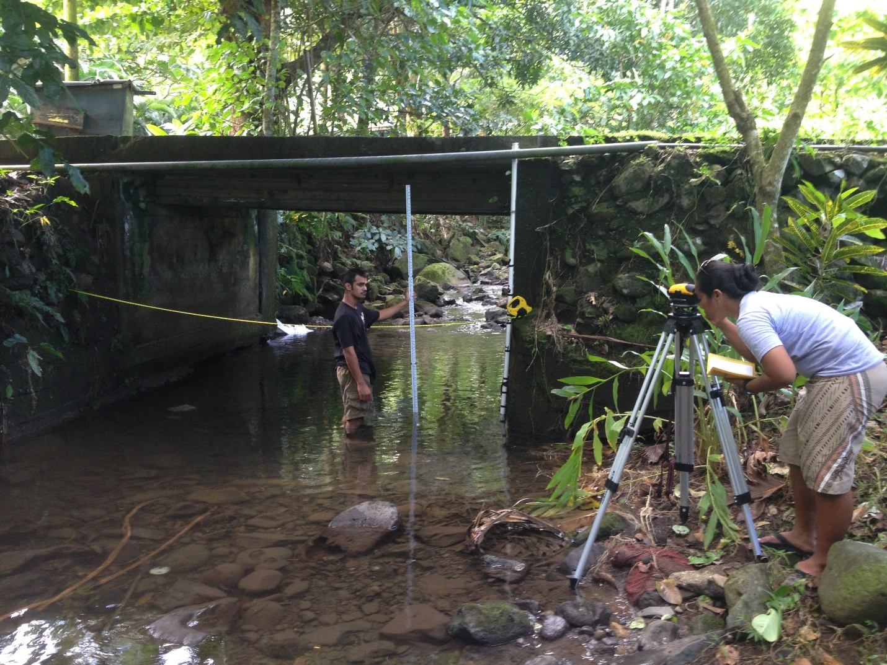

Figure 3. Field assistants Rocco Tinitali and Valentine Vaeoso surveying the stream cross-section at site N2, under baseflow conditions. Photo: Messina.

Stream stage was recorded at 15 minute intervals at both sites using a data-logging pressure transducer (PT) installed in a PVC pipe stilling well. PT’s record the total hydrostatic pressure and must be corrected for atmospheric pressure. PT pressure data is converted to stage height by subtracting simultaneously recorded barometric pressure from the PT pressure data (Equation 2).

|  |  |  |
| --- | --- | --- |
|  | $$Stage = \frac{PT-Baro}{g* ρ*100}$$ | 2 |
| where Stage is stage height (cm), PT is recorded pressure from the PT (hPa ), Baro is barometric pressure (hPa), g is gravity (9.81m1s-2), ρ is density of water (1kg1 L-1), and 100 (cm1 m-1). | | |

Barometric pressure from three stations was used: a Davis weather station (Wx), a NOAA tide station (NSTP6), and a NOAA Climate Observatory at Tula (TULA) (Figure 1, top right). A Davis Vantage Pro 2 weather station (Wx) was installed in nearby Faga’alu watershed, near the stream mouth. Where barometric data from Wx was not available, data from a NOAA National Data Buoy Center tidal station (NSTP6) in Pago Pago Harbor (4 km away), or from a NOAA Climate Observatory at Tula (17.5 km away).

3. Results

Stage Data

Stream stage was calculated from PT data at N1 and N2 and barometric pressure recorded at the weather stations (Figure 4). The PT at N1 was vandalized and destroyed in July 2013 so no data was available until it was reinstalled in March 2014. Data for N2 was not recorded from May-October 2014 because its memory was filled, and could not record any more data. Stage varied from 1-138 cm at N1 and from 30-117 at N2.

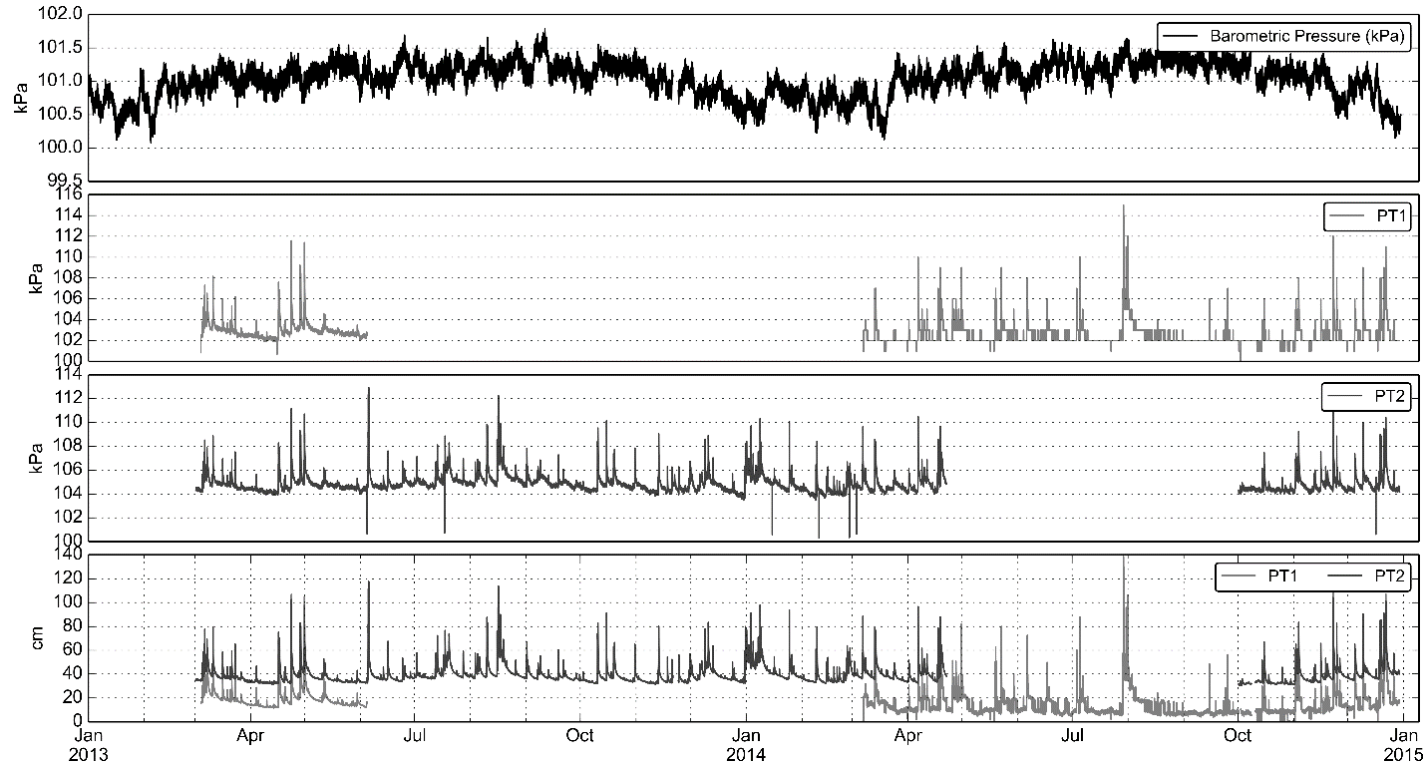

d)

c)

b)

a)

Figure 4. (a) Barometric pressure, (b-c) PT pressure at N1 and N2, and (d) stream stage at N1 and N2 during the study period.

Site N1

Site N1 is located at a bridge on Highway 001, the island’s most heavily trafficked road (Figure 5). Due to the complex shape of the bridge culvert, and significant sediment deposits in the east section of the culvert, the PT was installed immediately downstream of the bridge where the banks are stabilized by concreted rip-rap, and the stream bed is a concrete footing. No sediment build up was observed during the monitoring period and no erosion of the concrete footing is possible.

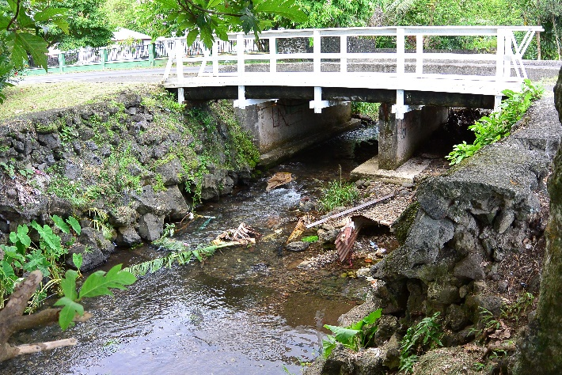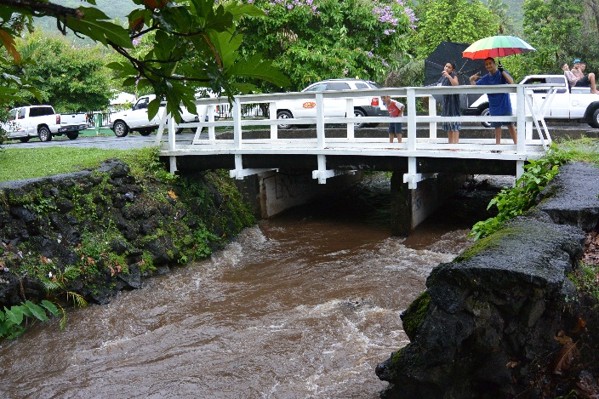

PT location

**b)**

**a)**

Figure 5. Site N1 under (a) baseflow and (b) stormflow conditions. Surveyed cross-section location illustrated in (a); PT location illustrated in (b). Photos: Messina.

The stream cross section at Site N1 was approximately trapezoidal (Figure 5), with some large rip rap boulders at the toe of the stream bank slope, and along the stream banks. The slope profile is fairly gentle (0.0013 m/m), which reflects its location down on the flat part of the valley bottom, near the outlet to the ocean.

Figure 6. Surveyed cross section and longitudinal profile at Site N1 (downstream) outlet of the LOWER subwatershed, and TOTAL watershed. PT location is at 0 feet distance in the longitudinal profile.

Four discharge measurements were made at N1 (3/11/13 and 12/17/14) over stream stages ranging from 11-28 cm (Figure 7). Discharge measurements using the AV method ranged from 39-232 L/sec. Using the cross-section measured with the top-setting wading rod during the AV measurement, and flow velocity calculated by Manning’s equation (n=0.067), discharge varied from 20-212 L/sec. The surveyed cross-section and Manning’s equation were used to calculate discharge over the range of measured stage (1-138 cm), and compare with the power function fit to the AV discharge measurements.

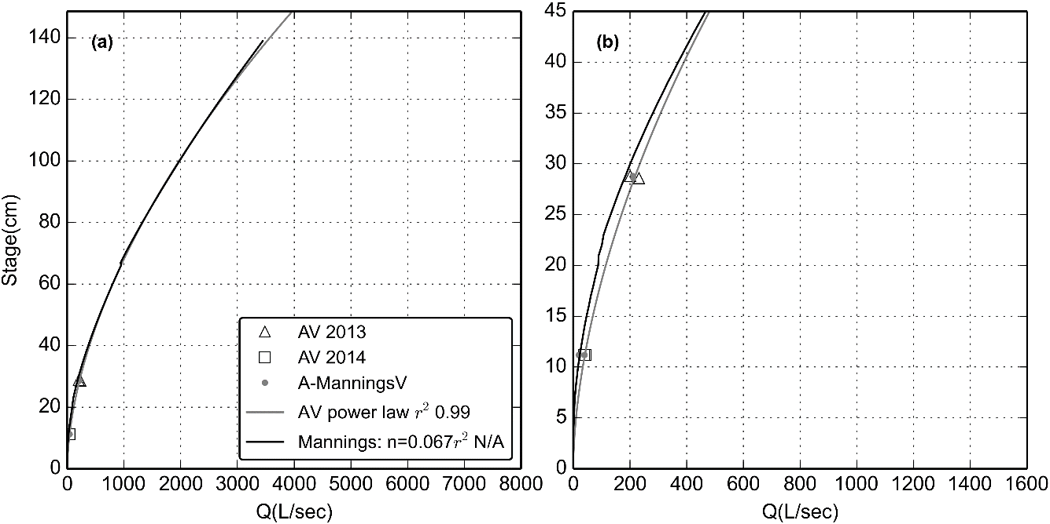

Figure 7. Stage-Discharge rating curves for Site N1.

Site N2

Site N2 is located at a small bridge on a village road, near the furthest upstream houses (Figure 8). This site is not the outlet of the UPPER subwatershed but was chosen because it has stabilized banks, and is only about 100m downstream of the UPPER subwatershed. The water depth was relatively high at low flow, compared to Site N1, and the stream bed is composed of loose gravel and cobbles, unlike the cement bed at N1.

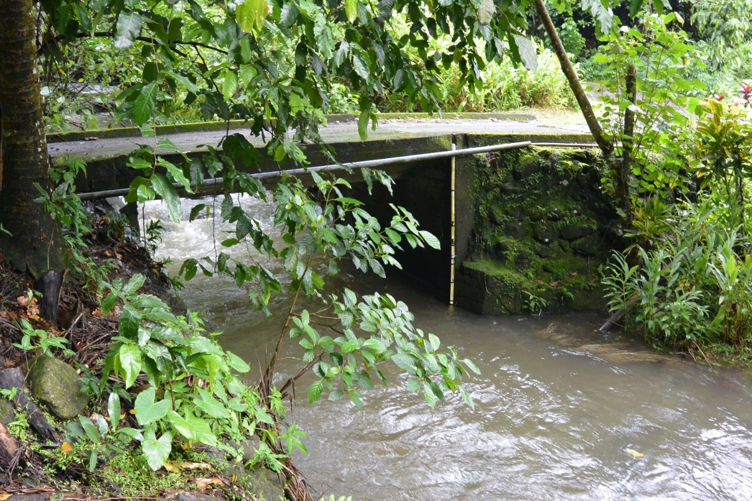

PT location

Figure 8. Site N2 under stormflow conditions. The PT is installed in the white, PVC tube attached to the downstream side of the bridge.

The stream cross section at site N2 is fairly flat with little variation in depth (Figure 9). The elevation profile showed the slope was slightly steeper than at N1, which is expected given its upstream location where the mountains steepen (Figure 9). The slope at N1 was 0.0023 m/m.

Figure 9. Surveyed cross section and longitudinal profile at Site N2 (upstream) outlet of the UPPER subwatershed. PT location is at 0 feet distance in the longitudinal profile.

Due to the high depth at N2 under all flow conditions, it was difficult to measure discharge by wading, so only two discharge measurements were made over stream stage from 36-45 cm (Figure 10). Given the limited range of stream stages for these measurements, the rating curve cannot be constructed from measurements alone. Manning’s equation and the surveyed cross-section were used to calculate discharge over the range of stages measured by the PT.

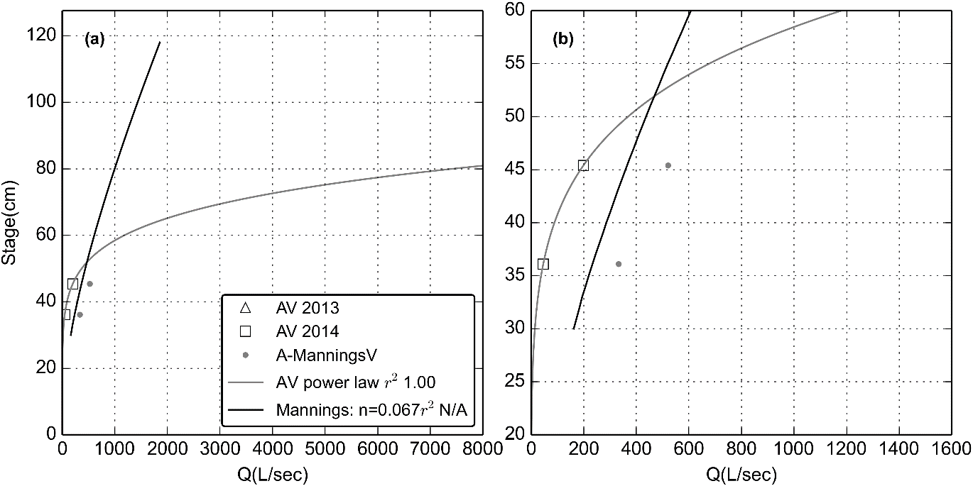

Figure 10. Stage-Discharge rating curves for Site N2.

4. Discussion

For Site N1 (downstream), the power law rating curve and discharge calculated by Manning’s equation were very similar (Figure 7). Given the limited range of flow conditions measured using the AV method, it is probably best to use the rating curve from Manning’s equation to extrapolate the higher discharge values. The AV discharge measurements were useful for calibrating Manning’s n parameter. Where it may be uncertain to pick a Manning’s value based on some visual assessment, it is helpful to vary Manning’s n until it approximates the AV measurement.

For Site N2, the power law rating curve and Manning’s calculations were not similar (Figure 10). Discharge measured using the AV method was also not similar to discharge predicted by Manning’s equation. Unfortunately, there are not enough AV discharge measurements to construct a rating curve using a power function so Manning’s equation and the surveyed cross-section are the only option for constructing a rating curve at Site N2. It will be important to compare discharge time series at N1 and N2 during storm events to see if they make agree with each other.

It would be helpful to make more discharge measurements at both locations over a larger range of stages to add certainty to these rating curves. While the stream cross-section at N1 is unlikely to change, unless there is sediment deposition, it would also be helpful to survey the cross-section at N2 to determine if the bed is stable. While the banks are a stable bridge culvert, there may be reworking of the gravel/cobble bed.

5. Conclusion

This paper presented the construction of stage-discharge rating curves for two stream-gaging sites on Papa Stream in Nu’uuli watershed. Due to the limited range of stages where discharge was measured in situ with the area-velocity method, Manning’s equation and a surveyed stream cross-sections were used to create a stage-discharge rating curve for each stream. The area-velocity discharge measurements were useful for calibrating Manning’s n parameter and reduce some uncertainty in using Manning’s equation with no field data.

The results of this analysis now make it possible to model discharge during the study period, providing critical water discharge data for calculating sediment loading. Future analysis using the developed rating curves will model discharge and suspended sediment loading from the undisturbed and disturbed subwatersheds of Nu’uuli watershed, to determine relative contributions and the impact of human disturbance on sediment yield.

**Acknowledgements.** The author would like to thank Sunia Interns Rocco Tinitali and Valentine Vaeoso for assistance with stream surveying. The American Samoa Coral Advisory Group (CRAG) also provided funding and support for this project.

References

Bégin, C., Brooks, G., Larson, R. a., Dragićević, S., Ramos Scharrón, C.E., Coté, I.M., 2014. Increased sediment loads over coral reefs in Saint Lucia in relation to land use change in contributing watersheds. Ocean Coast. Manag. 95, 35–45. doi:10.1016/j.ocecoaman.2014.03.018

Eyre, P.R., 1989. Ground-water quality reconnaissance, Tutuila, American Samoa, U.S. Geological Survey Water Resources Investigations Report 94-4142. Honolulu, HI.

Izuka, S.K., Giambelluca, T.W., Nullet, M.A., 2005. Potential Evapotranspiration on Tutuila , American Samoa. U.S. Geological Survey Scientific Investigations Report 2005-5200.

NOAA’s Ocean Service, Coastal Services Center, 2010. 2010 C-CAP Land Cover, Territory of American Samoa, Tutuila.

Turnipseed, D.P., Sauer, V.B., 2010. Discharge Measurements at Gaging Stations, in: U.S. Geological Survey Techniques and Methods Book 3, Chap. A8. Reston, Va., p. 87.

Wong, M., 1996. Analysis of Streamflow Characteristics for Streams on the Island of Tutuila, American Samoa. U.S. Geological Survey Water-Resources Investigations Report 95-4185.